Demonstrated that you can only read from the read replica database– us-west-1a

DATABASE|UDACITY1|REPLICA
CONNECTING TO THE REPLICA OF DB
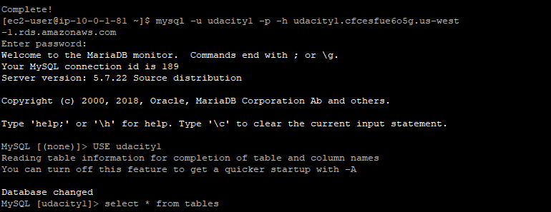

TABLES CREATED AT PRIMARY DATABASE IS REPLICAED


DATABASE|REPLICA – Not able to write only able to read.
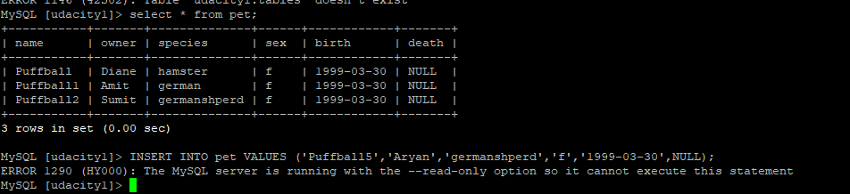

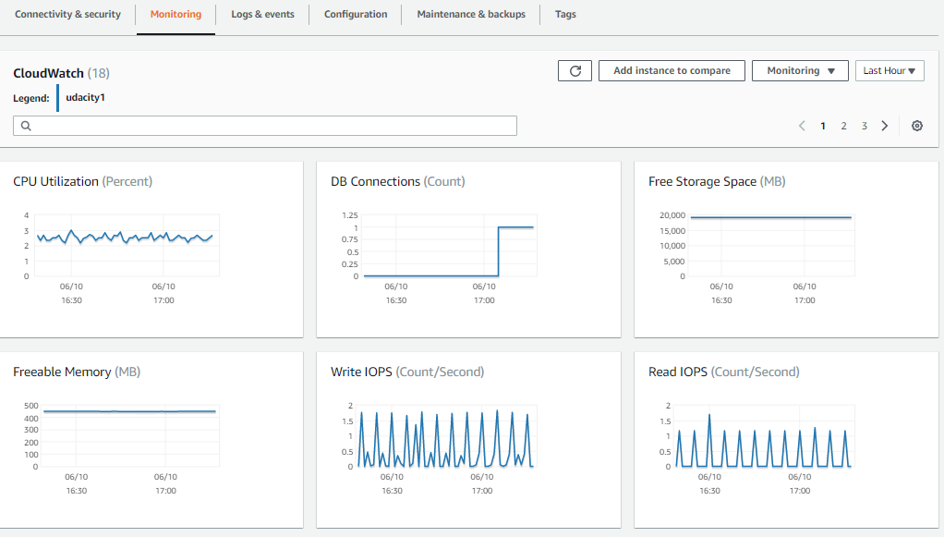
SCREENSHOT OF THE CONFIGRATION BEFORE PROMOTING THE REPLICA

